GITHUB 2ND TASK.

- Install GIT

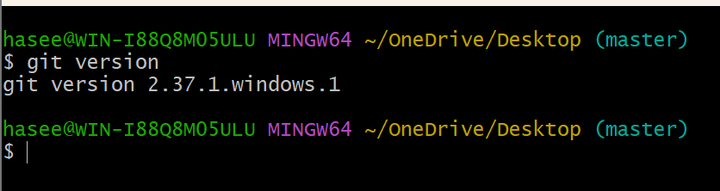

- Create a repo in GITHUB with README.md and ignore file.
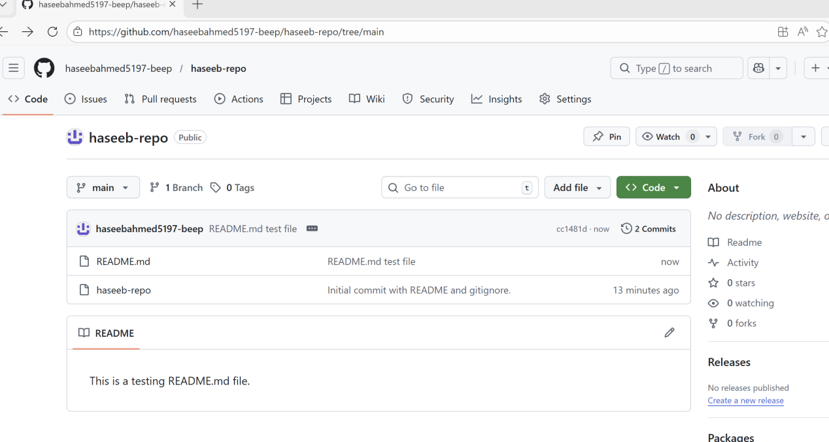
- Clone the created repo to Local

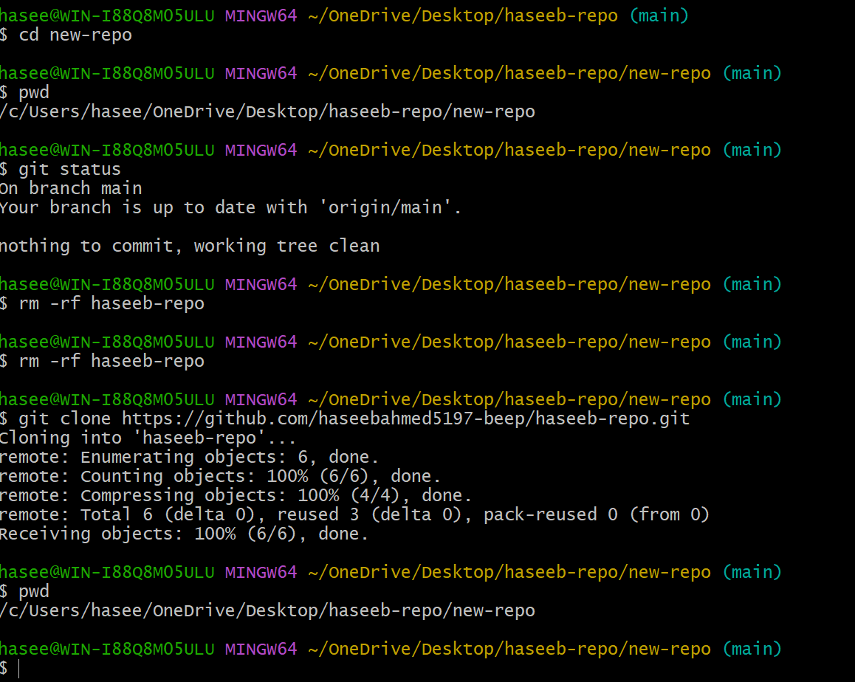

- Create two files in a local repo.

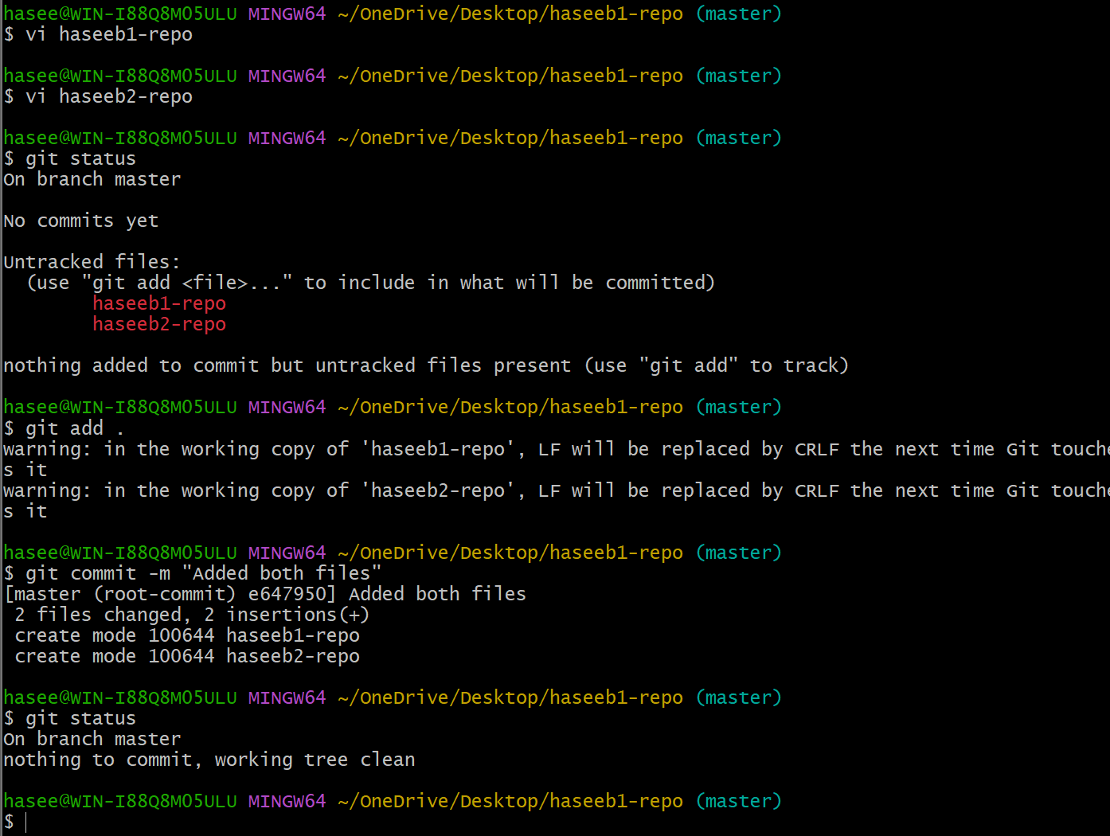
- Commit two files and push to central Repository.
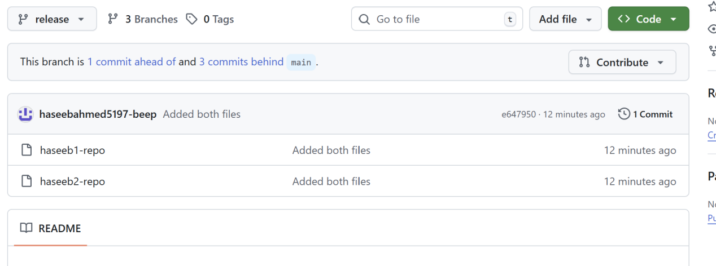

- Create a branch in local and create a sample file and push to central.

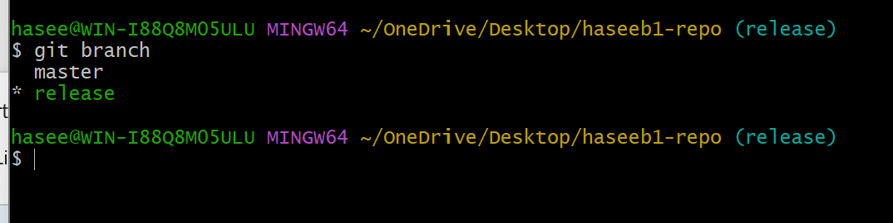
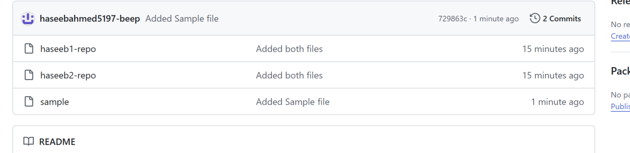
- Create a branch in github and clone that to local.

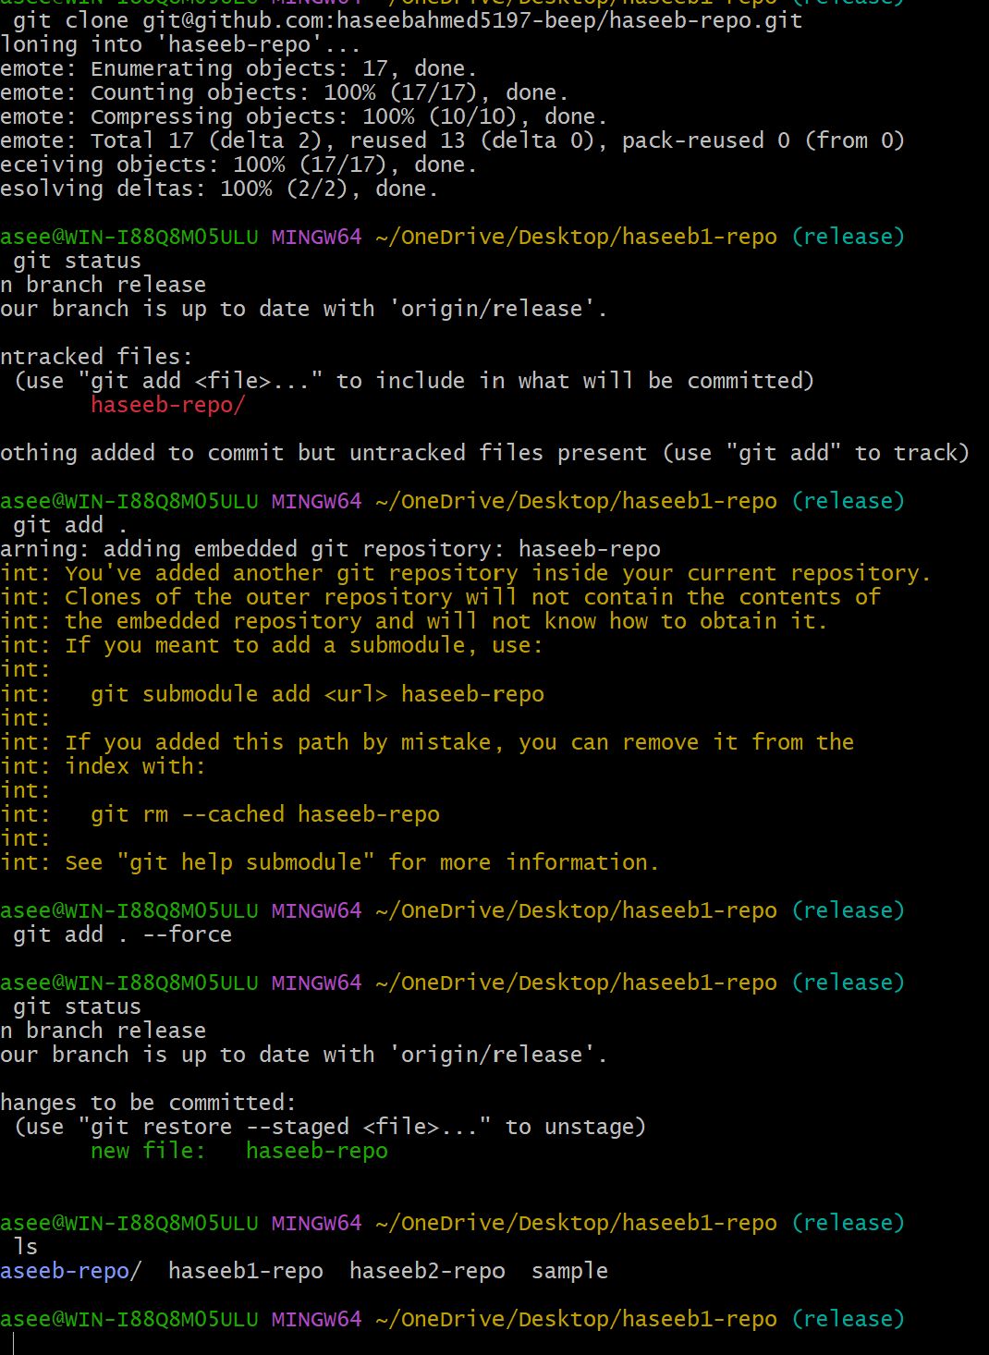

- Merge the created branch with master in git local.

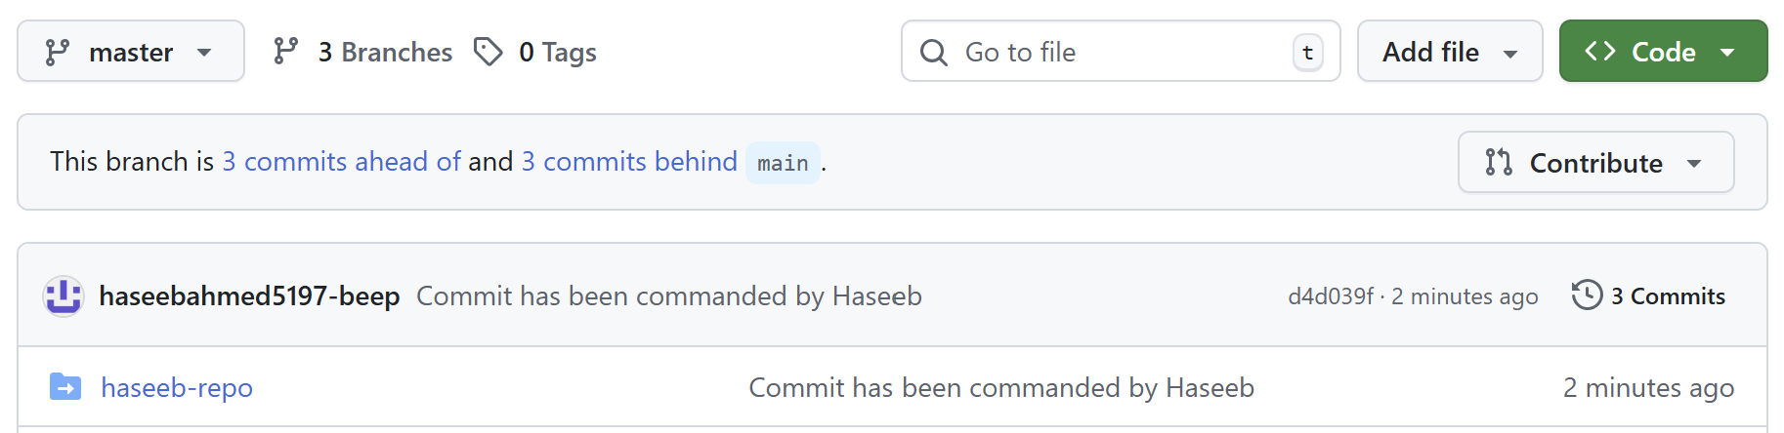
- Merge the created branch with master in github by sending a pull request.

- Create a file in local and send that to branch in github.

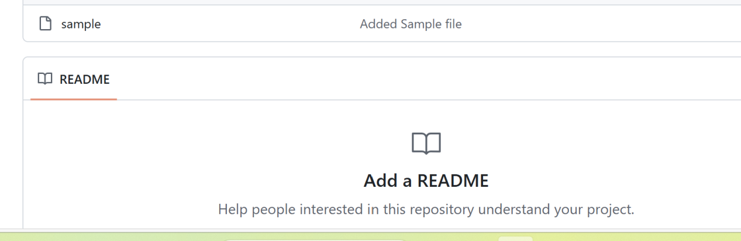

- Clone only a branch from github to local.

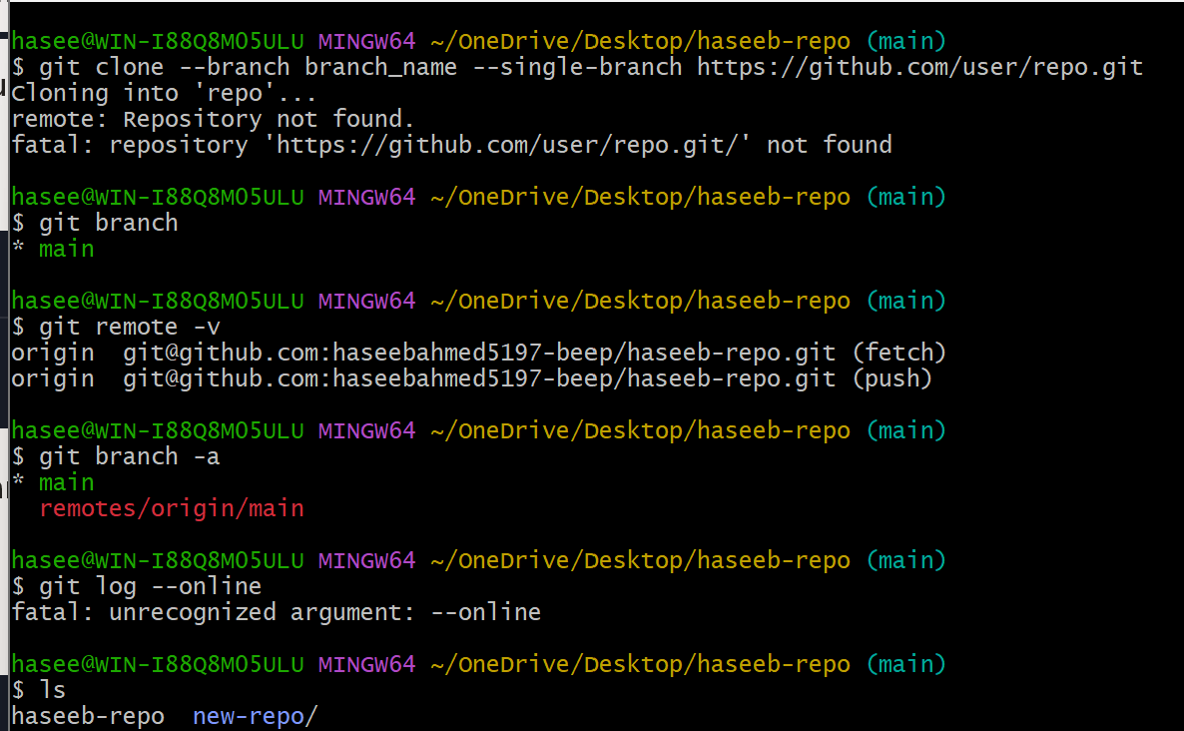

- Create a file with all passwords and make that untrackable with git.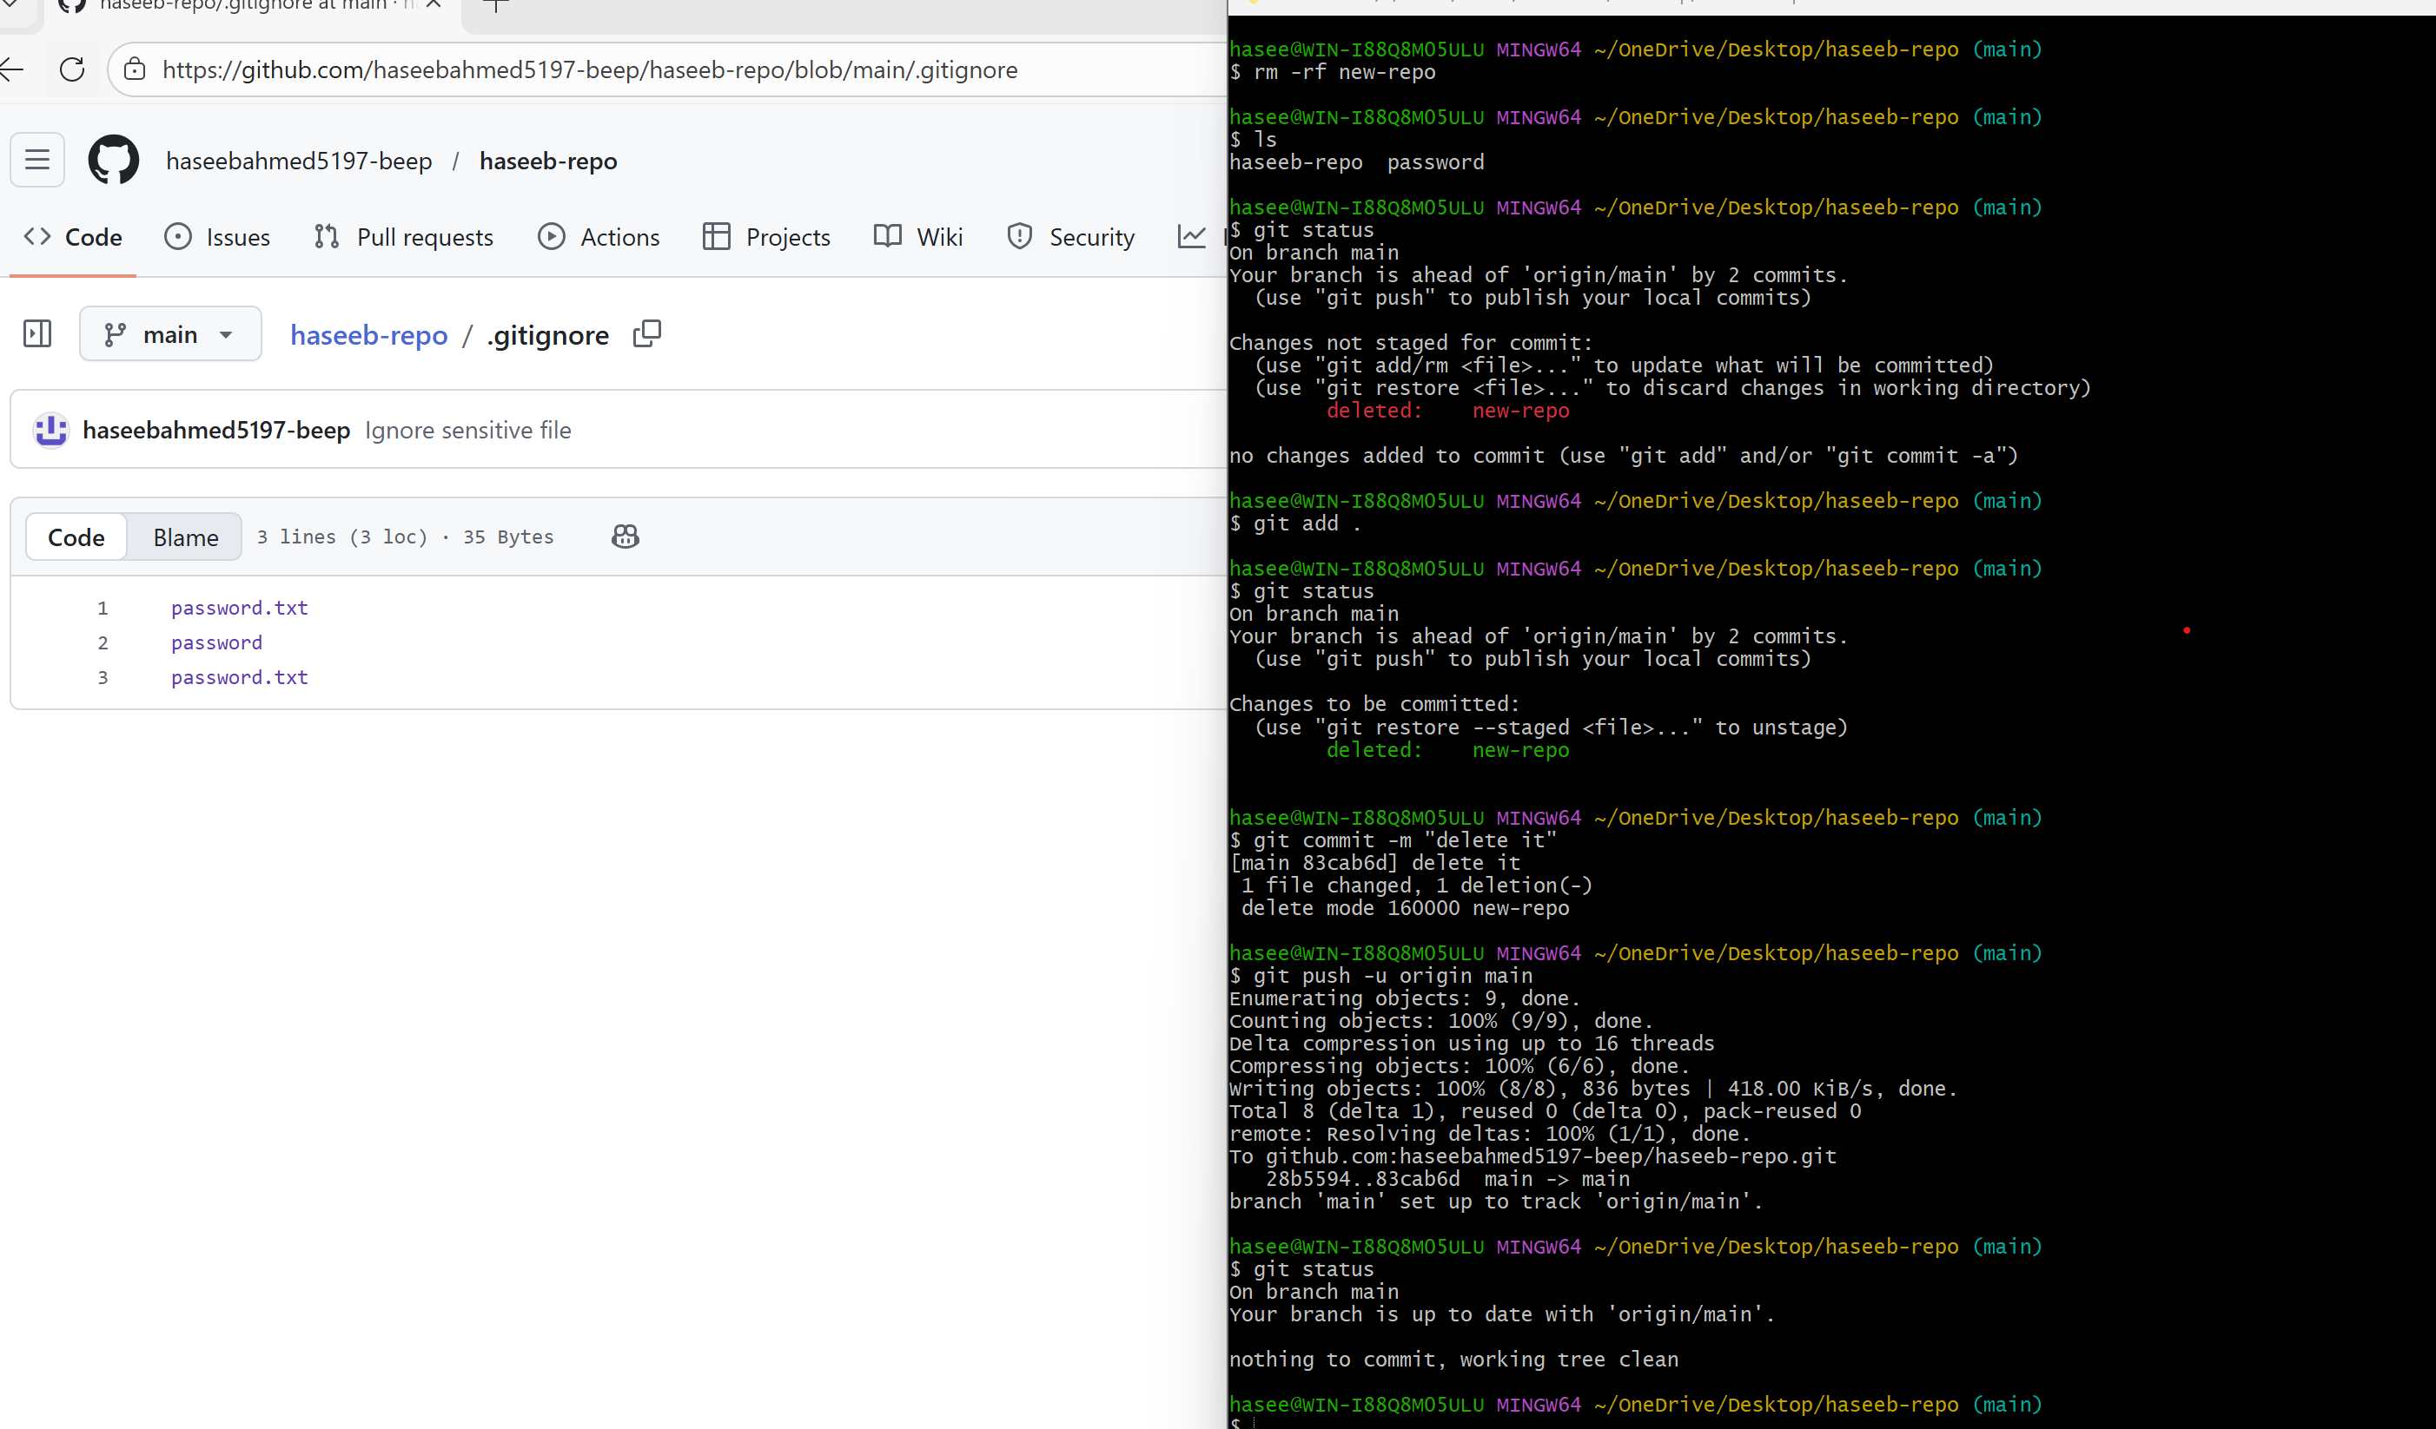

- Make a commit and make that commit reset without savings changes.
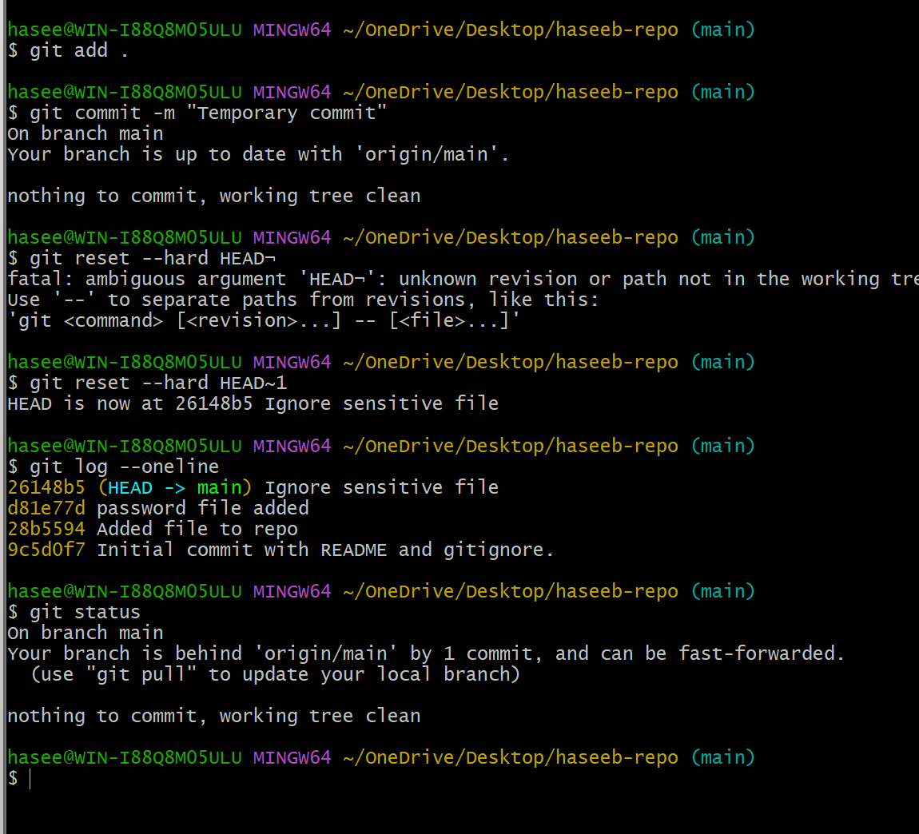

- Revert a commited commit to the older version.
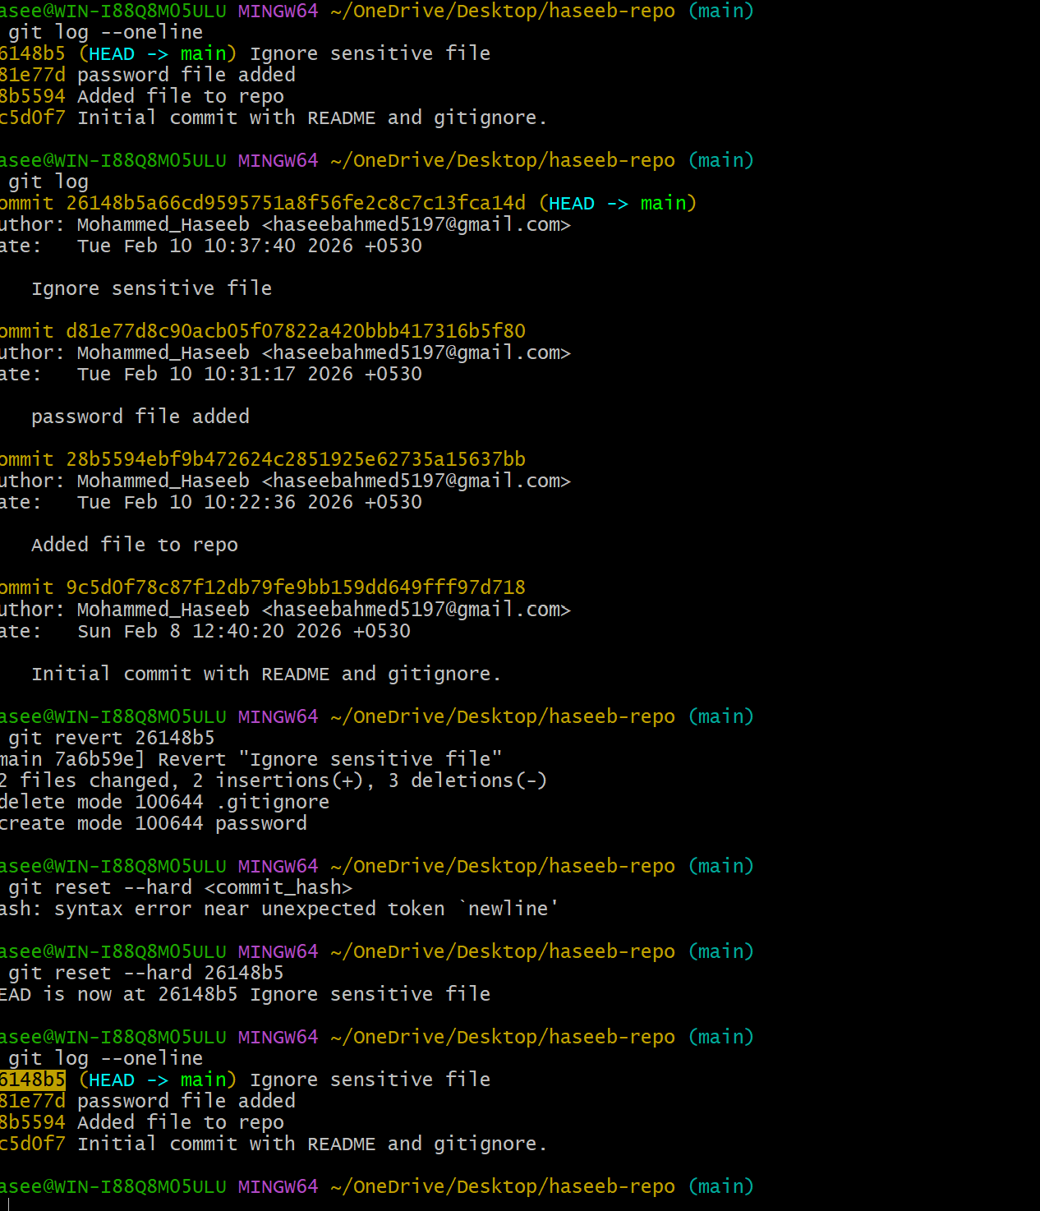

- Push a file to stash without savings the changes and work on another file
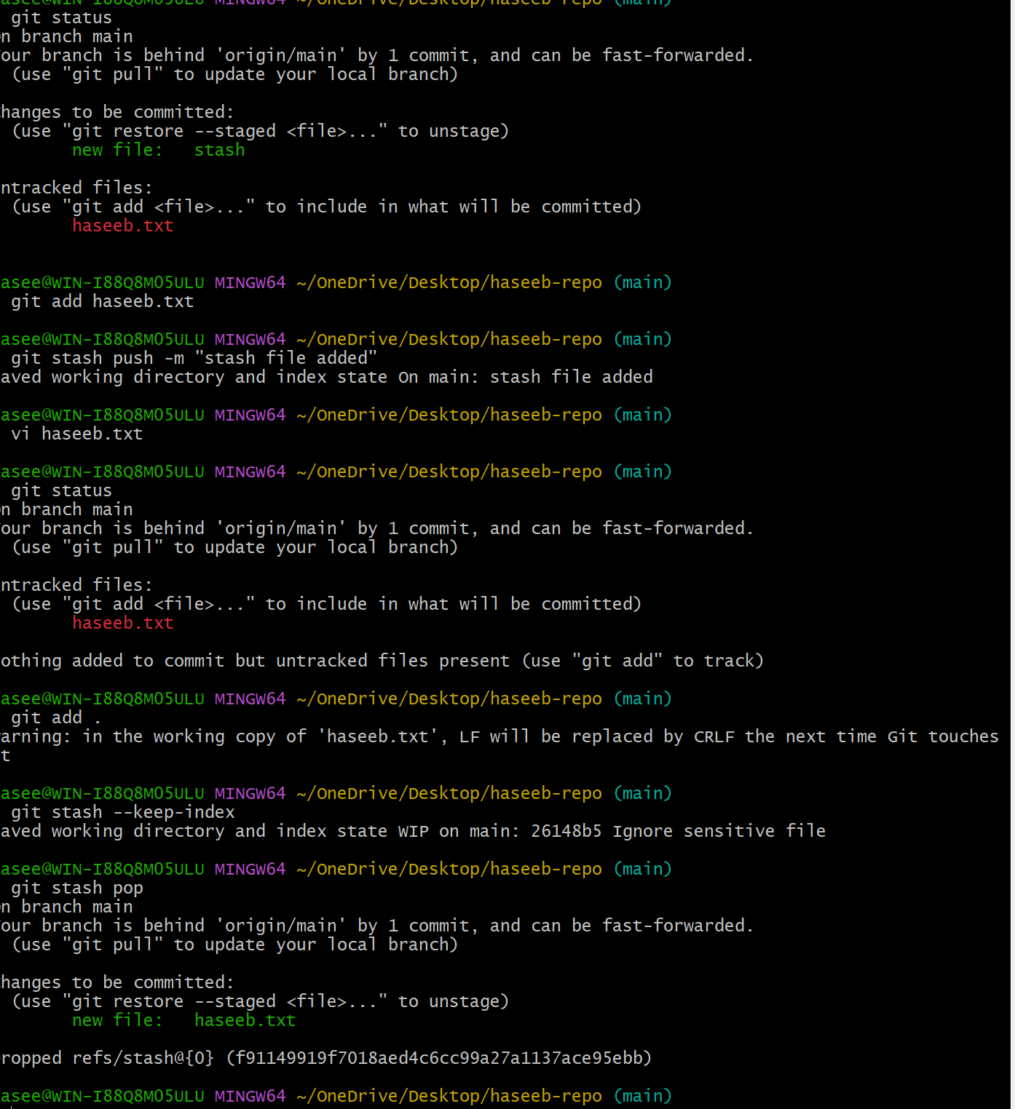

- Undo the stash file and start working on that again.
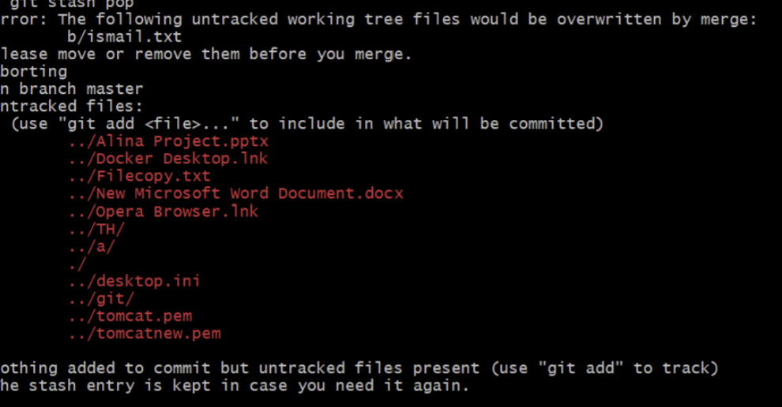
- Generate a SSH Keygen and configure it to github
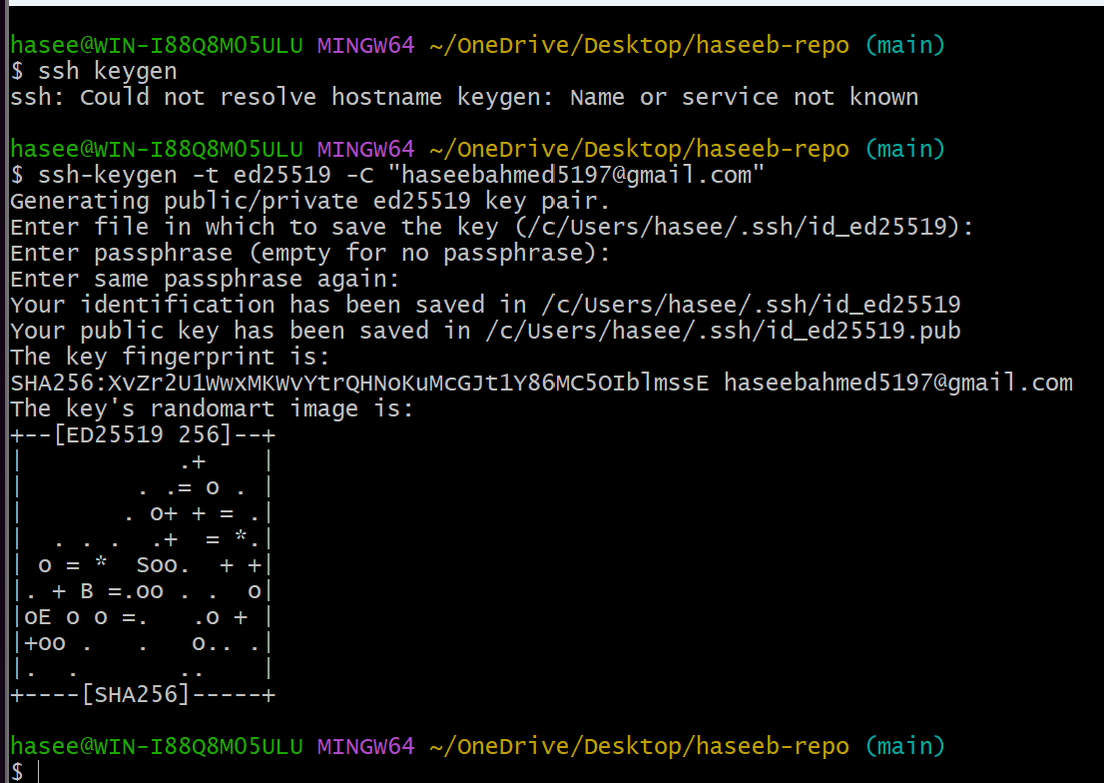
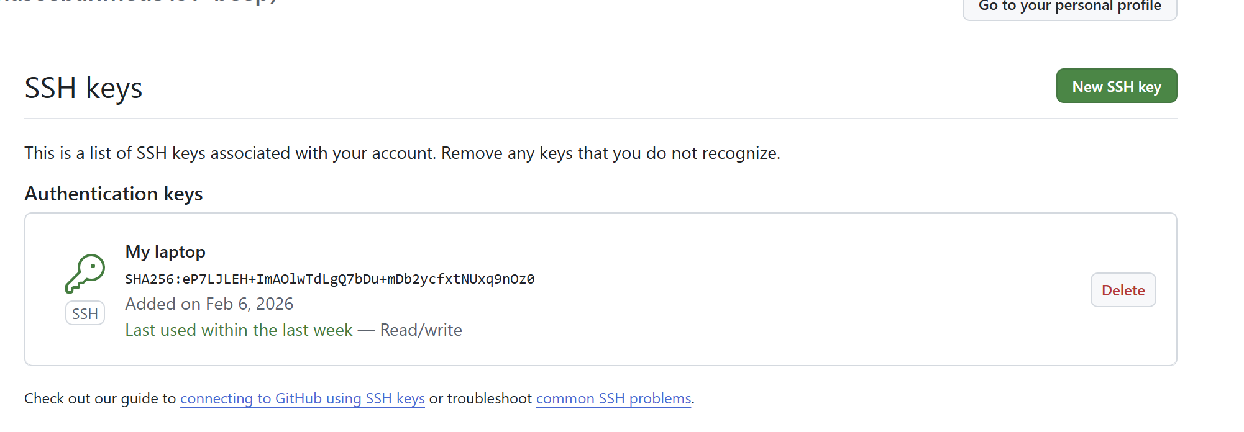

- Configure Webhooks to github
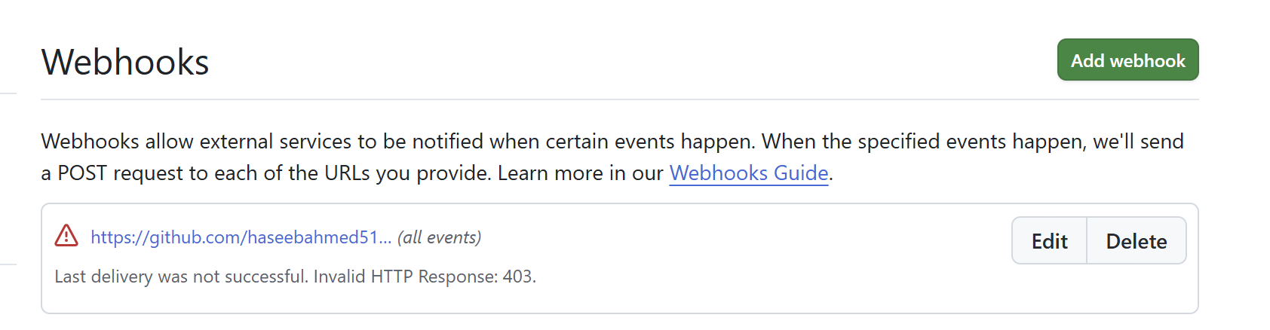
- Basic understanding of a gitfile.
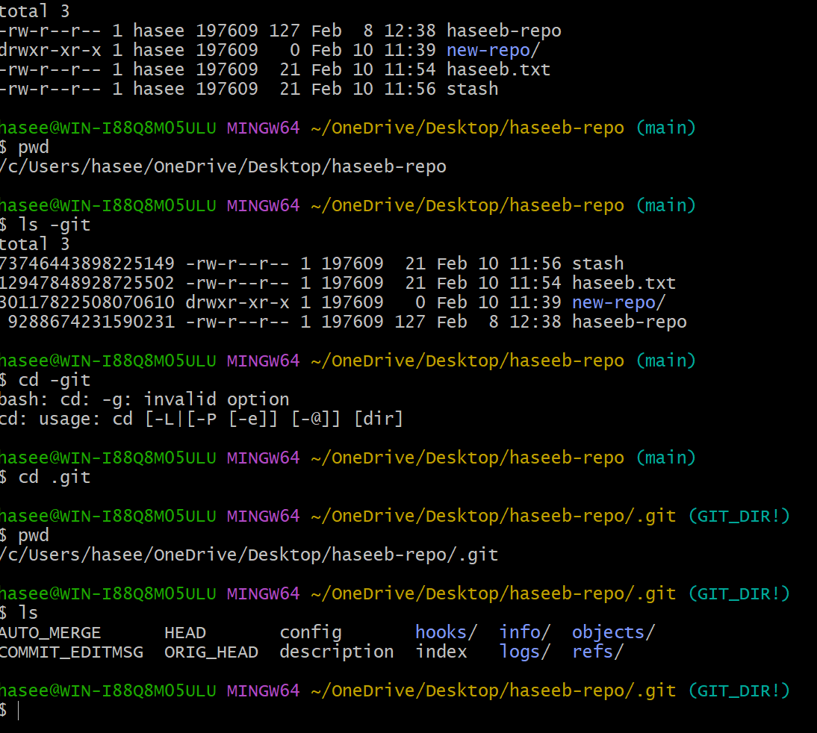

- Check all the logs of git.
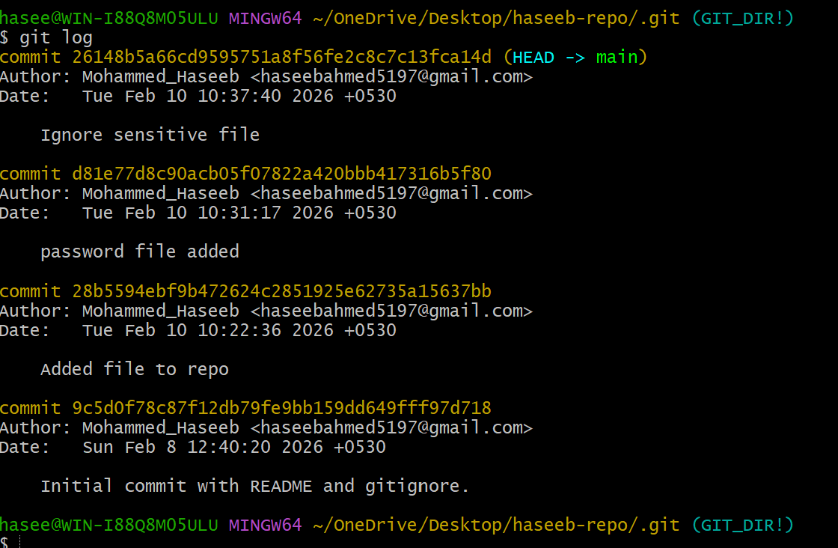

- Rename the commit message
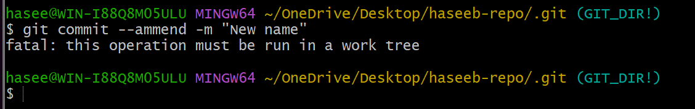

- Merge multiple commit into single commit.

